**Database Lab Report**

**Name : Hasin Almas Sifat**

**ID: 22-48679-3**

1. **SELECT \***

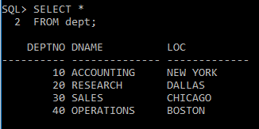 **2 FROM dept;**

1. **SELECT deptno, loc**

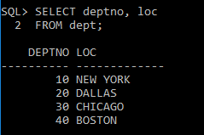**2 FROM dept;**

1. **SELECT ename, sal, sal+300**

**2 FROM emp;**

1. 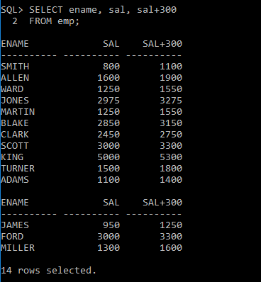**SELECT ename, sal, 12*sal+100**

**2 FROM emp;**

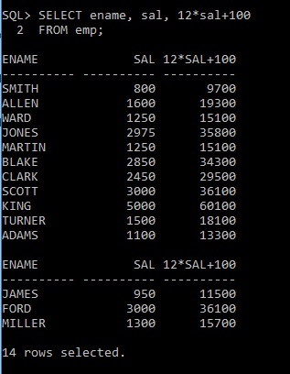

1. **SELECT ename, sal, 12*(sal+100)**

**2 FROM emp;**

1. 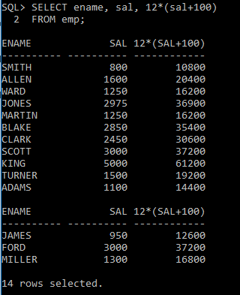 **SELECT ename, job, comm**

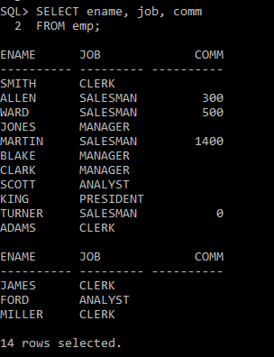 **2 FROM emp;**

1. 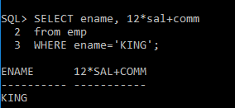**SELECT ename, 12*sal+comm**

**2 from emp**

**3 WHERE ename='KING';**

1. **SELECT ename AS name, sal salary**

**2 from emp**

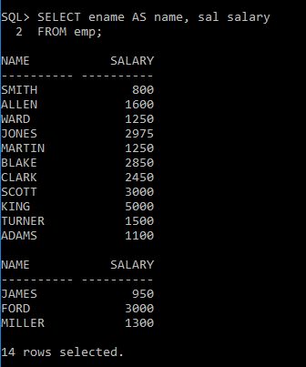 **3 WHERE ename='KING';**

1. **SELECT ename "NAME",**

**2 sal*12 "Annual Salary"**

**3 FROM emp;**

1. 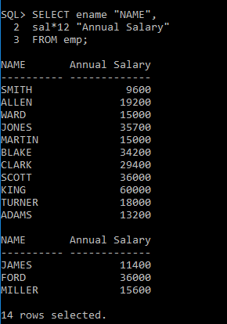 **SELECT ename||job AS "Employees"**

**2 FROM emp;**

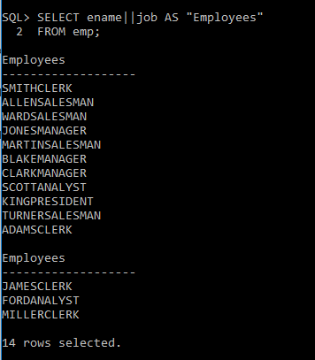

1. **SELECT ename||' '||'is a'||' '||job**

**2 AS "Employee Details"**

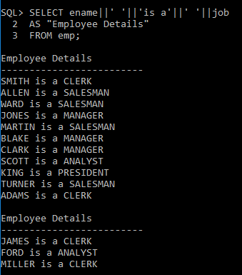 **3 FROM emp;**

1. **SELECT deptno**

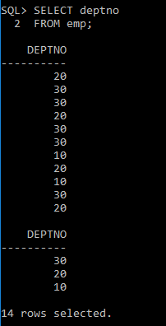 **2 FROM emp;**

1. 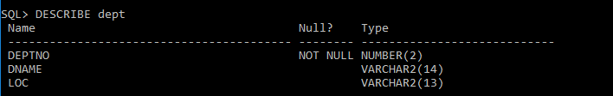**DESCRIBE dept**